**NJERU OLIVER NJIRU 663565**

1. Develop the database for the Mountain View Hospital with all the tables and business rules explained above;

(*Get screen captures of the DB design and copy into Word for submission*).

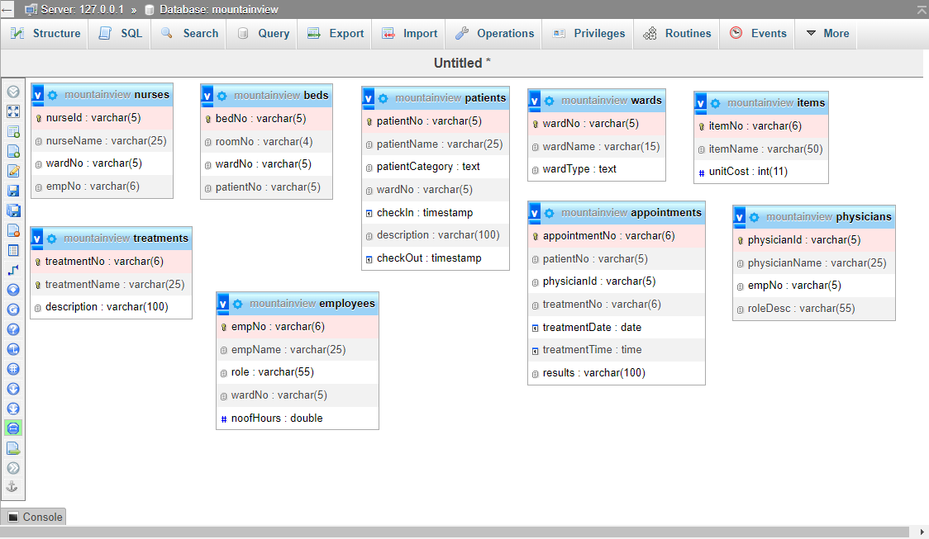

1. Populate the tables with sample data (*ensure referential integrity* in the data samples); Insert at least 10 records into the Patient table and 5 records in each of all the other tables. Ensure one of the patients contains your particulars – a record with your name is mandatory.

(*Get screen captures of the inserted data in browse mode and copy into the word document for submission);*

Appointments

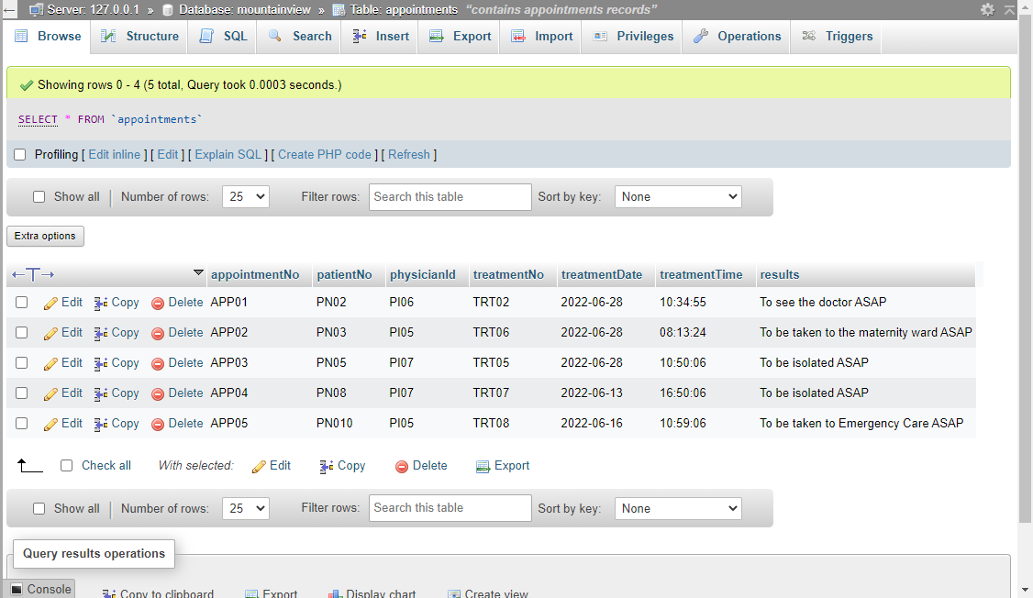

Beds

Employees

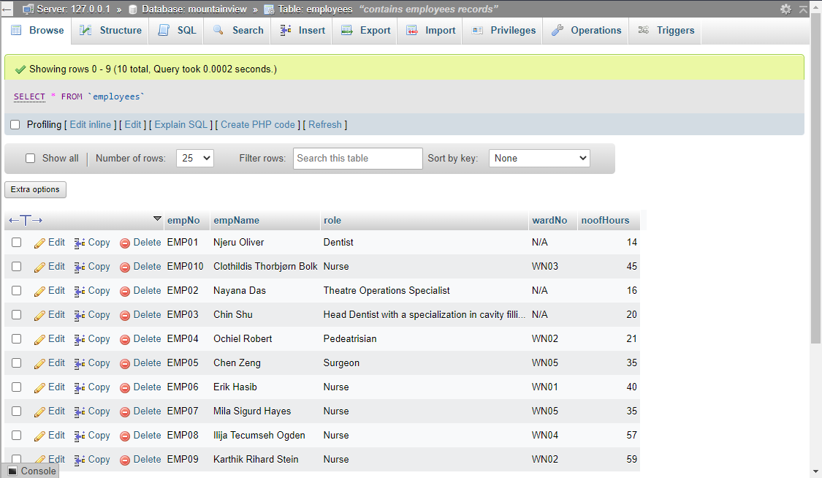

Items

Nurses

Patients

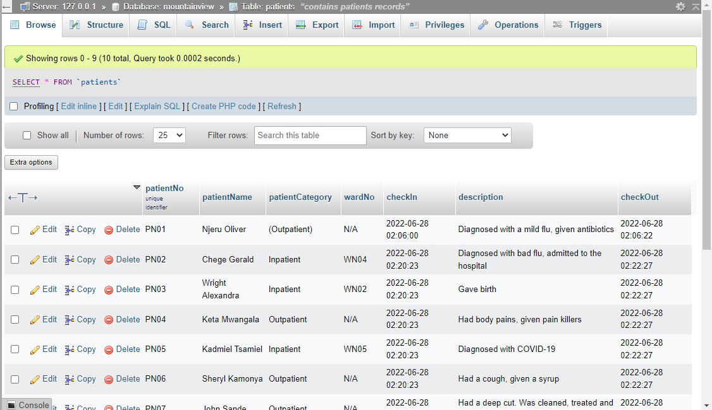

Physicians

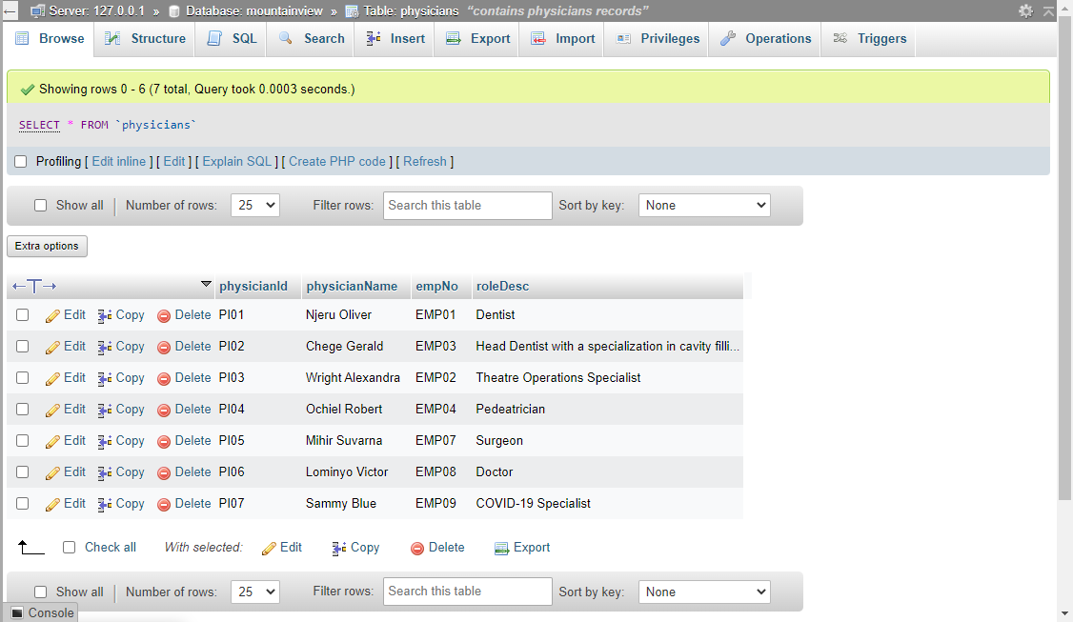

Treatments

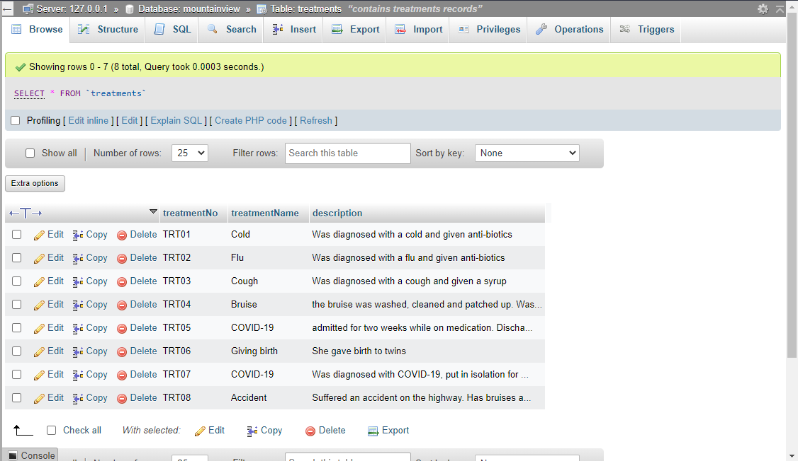

Wards

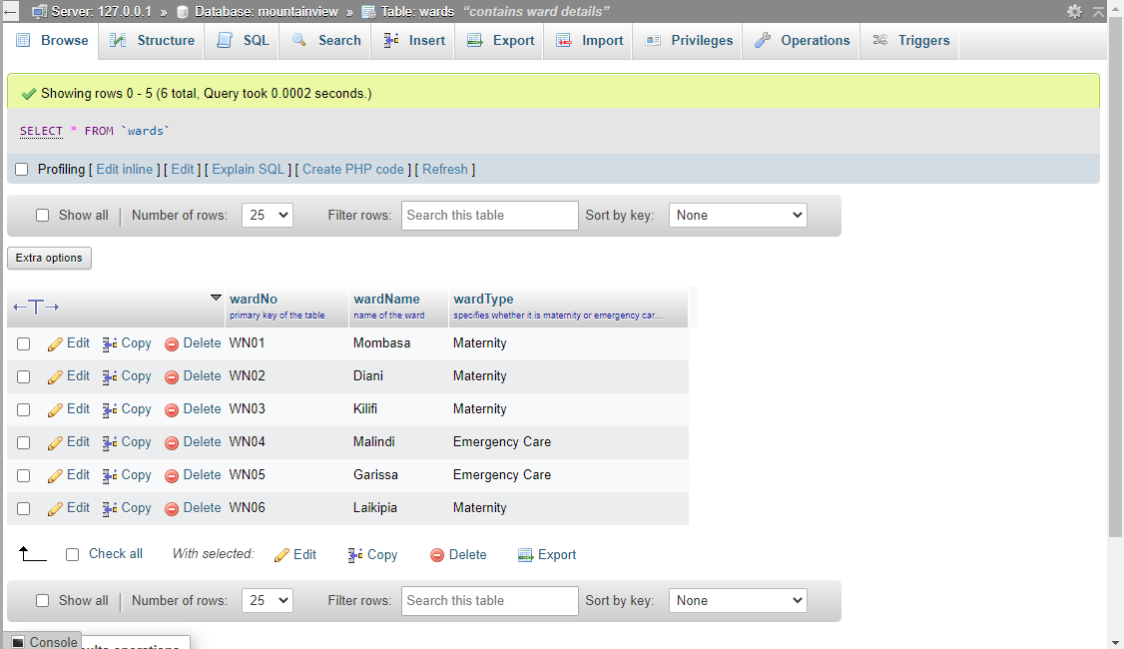

1. Use SQL to:
2. Write at least one **data insertion SQL statement** for each of the tables; *Copy your SQL statement and result into the word document for submission;*

*Appointments*

1. Top of Form

INSERT INTO `appointments` (`appointmentNo`, `patientNo`, `physicianId`, `treatmentNo`, `treatmentDate`, `treatmentTime`, `results`) VALUES ('APP05', 'PN010', 'PI05', 'TRT08', '2022-06-16', '22:48:44', 'To be taken to Emergency Care ASAP')

The result is the values after VALUES in the brackets, from ‘APP05’ to ‘To be taken to Emergency Care ASAP’ will be inserted in the appointments table from ‘appointmentNo’ column to ‘results’ column respectively

Beds

INSERT INTO `beds` (`bedNo`, `patientNo`, `roomNo`, `wardNo`, `patientNo`) VALUES ('BN05', 'RM02', 'WN05', 'PN10')

The result is the values after VALUES in the brackets, from ‘BN05’ to ‘PN10’ will be inserted in the beds table from ‘bedNo’ column to ‘patientNo’ column respectively

Employees

INSERT INTO `employees` (`empNo`, `empNo`, `role`, `wardNo`, `noofHours`) VALUES ('EMP01', 'Njeru Oliver', 'Dentist', 'WN04', '14')

The result is the values after VALUES in the brackets, from ‘EMP01’ to ‘14’ will be inserted in the employees table from ‘empNo’ column to ‘noofHours’ column respectively

Items

INSERT INTO `items` (`itemNo`, `itemName`, `unitCost`) VALUES ('ITM05', 'ARINEO Stainless Steel 41', '4500')

The result is the values after VALUES in the brackets, from ‘ITM05’ to ‘4500’ will be inserted in the items table from ‘itemNo’ column to ‘unitCost’ column respectively

Nurses

INSERT INTO `nurses` (`nurseId`, `nurseName`, `wardNo`, `empNo`) VALUES ('NI04', 'Karthik Rihard Stein', 'WN02', 'EMP09')

The result is the values after VALUES in the brackets, from ‘NI04’ to ‘EMP09’ will be inserted in the nurses table from ‘nurseId’ column to ‘empNo’ column respectively

Patients

INSERT INTO `patients` (`patientNo`, `patientName`, `patientCategory`, `wardNo`, `checkIn`, `description`, `checkOut`) VALUES ('PN08', 'Taigu Wachira', 'Inpatient', 'WN04', '2022-06-28 02:20:23', 'Diagnosed with COVID-19', ''2022-06-28 02:22:27')

The result is the values after VALUES in the brackets, from ‘PN08’ to ‘2022-06-28 02:22:27’ will be inserted in the employees table from ‘patientNo’ column to ‘checkOut’ column respectively

Physicians

INSERT INTO `physicians` (`physicianId`, `physicianName`, `empNo`, `roleDesc`) VALUES ('PI07', 'Sammy Blue', 'EMP09', 'COVID-19 Specialist')

The result is the values after VALUES in the brackets, from ‘PI07’ to ‘COVID-19 Specialist’ will be inserted in the employees table from ‘physicianId’ column to ‘roleDesc’ column respectively

Treatments

INSERT INTO `treatments` (`treatmentNo`, `treatmentName`, `description`) VALUES ('TRT08', 'Accident', 'Suffered an accident on the highway. Has bruises all over, internal bleeding and a fractured leg')

The result is the values after VALUES in the brackets, from ‘TRT08’ to 'Suffered an accident on the highway. Has bruises all over, internal bleeding and a fractured leg' will be inserted in the employees table from ‘treatmentNo’ column to ‘description’ column respectively

Wards

INSERT INTO `wards` (`wardNo`, `wardName`, `wardType`) VALUES ('WN06', 'Laikipia', 'Maternity')

The result is the values after VALUES in the brackets, from ‘WN06’ to ‘Maternity’ will be inserted in the employees table from ‘wardNo’ column to ‘wardType’ column respectively

1. Bottom of Form

ii) Write some five SQL **queries** to retrieve data from the database so as to include data from more than one table in a given query; the queries are of your own choice. At least one query should retrieve the record with your name as a patient.

CREATE VIEW patientward AS

SELECT patients.patientName, patients.patientCategory, wards.wardNo, wards.wardName, patients.description

FROM patients, wards

WHERE patients.patientName='Oliver Njeru';

SELECT * FROM patientward

The result will be patientName, patientCategory, wardNo, wardName and description where the patient name is Oliver Njeru

CREATE VIEW bedsward AS

SELECT beds.bedNo, beds.roomNo, beds.wardNo, wards.wardName

FROM beds, wards

WHERE beds.wardNo='WN02';

SELECT * FROM bedsward

The result will be bedNo, roomNo, wardNo, wardName where the wardNo is WN02

CREATE VIEW employeesward AS

SELECT employees.employeeName, employees.role, wards.wardName

FROM employees, wards

WHERE employees.role='Nurse';

SELECT * FROM employeesward

The result will be employeeName, role, wardName where the employeesrole is Nurse

CREATE VIEW appointmentspatient AS

SELECT appointments.appointmentNo, appointments.patientNo, patients.patientName

FROM appointments, patients

WHERE appointments.patientNo ='PN02';

SELECT * FROM appointmentspatient

The result will be appointmentNo, patientNo, patientName where the patientNo is PN02

CREATE VIEW appointmentsphysicians AS

SELECT appointments.appointmentNo, appointments.physicianId, physicians.physicianName

FROM appointments, physicians

WHERE appointments.patientNo ='PI05';

SELECT * FROM appointmentsphysicians

The result will be appointmentNo, physicianId, physicianName where the patientNo is PI05

(*Copy your SQL statements and results into the word document for submission);*

*Submit your Lab as a word/pdf document via Blackboard using the submission link for this assignment. All results should be screen captures copied into word as indicated above and labelled to indicate the respective section.*

Do NOT copy from a colleague or share your work, to avoid failing the Lab.